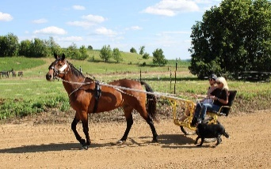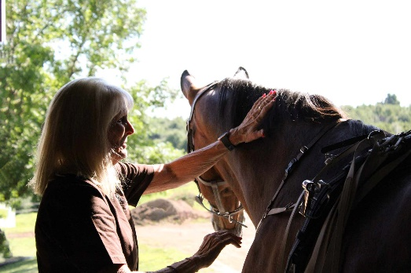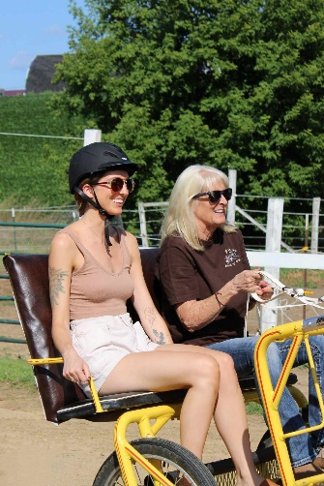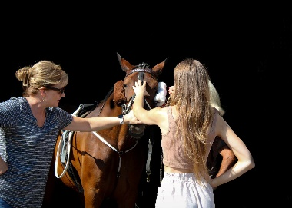

Hoof Beat Therapeutic Healing Center: A Legacy of Love and Healing

My lifelong passion for standardbred horses has evolved into a mission of healing and second chances. With over four decades in the industry, my journey began with the thrill of watching my grandfather's races and the acquisition of my first standardbred horse, HH Ballet.
I've done many different jobs in the horse racing industry. I've been an executive secretary for Minnesota Harness Racing, a superintendent of speed, and a race director for the Barron County Fair in Rice Lake, Wisconsin. My love for standardbred horses has always been a big part of my work. I've even spent 20 years on the board of directors for the Wisconsin Harness Horse Association.

But my connection with standardbred horses extends beyond racing and breeding. Inspired by my mother, Betty Strand, who found joy and comfort with horses during her battle with Alzheimer's, I founded Hoof Beat Therapeutic Healing Center. The center offers transformative healing experiences, with therapeutic sessions tailored to individual needs. These guided interactions with the horses can include grooming, riding, jog cart rides, or simply being in their presence. The intuitive connection between horse and human is at the heart of this therapy. Horses, being highly sensitive animals, mirror and respond to human emotions, fostering a safe and nurturing environment that encourages healing, self-awareness, and personal growth. Each therapy plan is personalized after an initial consultation to understand the individual's needs.

Our service caters to individuals of all ages and backgrounds, including those with physical disabilities and mental health challenges, or anyone seeking personal growth and emotional healing.

I also own eight retired standardbred horses, including HH Ballet, now 35 years old, and two Standardbred racehorses. Hoof Beat Therapeutic Healing Center is not only about healing humans but also about honoring and preserving the legacy of standardbred horses. It provides retired racers with new, meaningful opportunities to contribute. Every trot, nuzzle, and connection is a testament to the unique bond that only horses can create. My love for standardbred horses and commitment to their well-being shine brightly in Hoof Beat Therapeutic Healing Center. In my words, the journey has been the fulfillment of a lifelong dream. I now invite the community and the readers of the USTA to join me in spreading awareness and embracing the therapeutic wonders of standardbred horses.

Hoof Beat Therapeutic Healing Center stands as a tribute to a dream realized, a mother's love, and a magnificent breed. Through my dedication, I am not only enhancing lives but also building a legacy that resonates with every heartbeat of the horses I cherish.

“Testimony-- Spending time with Patty’s horses while I was recovering from an eating disorder was an important step for me. During a time when I felt very disconnected from myself and others, it was incredibly healing to connect with these sweet docile and highly intuitive creatures. They were a moment of respite from the chaos, and I am hugely grateful for the healing her horses provided for me!” --- Amanda Kistner

Our future plans include expanding our services to reach more individuals and communities. We are seeking partnerships with schools, healthcare providers, and other organizations to make our therapy more accessible. Additionally, we are committed to continuous training and development for our staff and volunteers to ensure the highest quality of care. Our goal is to bring the healing power of standardbred horses to as many people as possible, and we are excited about the journey ahead.

Interested individuals or their caregivers can contact us through email: hoofbeathealingcenter@yahoo.com or visit our website: Hoofbeattherapeutichealingcenter.com
Menomonie, WI

